Azure power shell and CLI
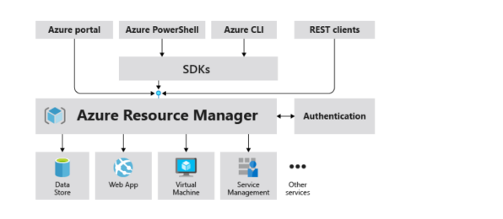
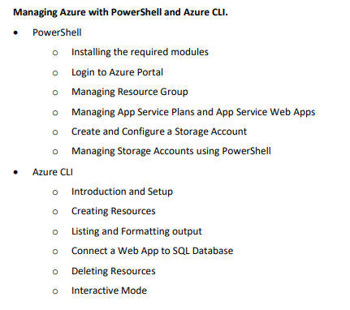

1. PowerShell Practice (Azure)
Use Azure PowerShell or local PowerShell

Step 1: Install Required Modules
Install-Module -Name Az -AllowClobber -Scope CurrentUser
Verify:
Get-Module -ListAvailable Az

Step 2: Login to Azure
Connect-AzAccount

Step 3: Create & Manage Resource Group
# Create Resource Group
New-AzResourceGroup -Name MyRG -Location eastus

# View Resource Groups
Get-AzResourceGroup

# Delete Resource Group
Remove-AzResourceGroup -Name MyRG

Step 4: App Service Plan + Web App
# Create App Service Plan
New-AzAppServicePlan -Name MyPlan -Location eastus -ResourceGroupName MyRG -Tier Free

# Create Web App
New-AzWebApp -Name mywebapp12345 -Location eastus -AppServicePlan MyPlan -ResourceGroupName MyRG

# List Web Apps
Get-AzWebApp

Step 5: Create Storage Account
New-AzStorageAccount `
-ResourceGroupName MyRG `
-Name mystorageacct123 `
-Location eastus `
-SkuName Standard_LRS

Step 6: Manage Storage (PowerShell)
# Get Storage Account
Get-AzStorageAccount -ResourceGroupName MyRG

# Create Storage Context
$ctx = (Get-AzStorageAccount -ResourceGroupName MyRG -Name mystorageacct123).Context

# Create Container
New-AzStorageContainer -Name mycontainer -Context $ctx

# Upload File
Set-AzStorageBlobContent -File "C:\test.txt" -Container mycontainer -Blob test.txt -Context $ctx

2. Azure CLI Practice
Use Azure CLI or Cloud Shell

Step 1: Install & Login
az login

Step 2: Create Resource Group
az group create --name MyRG --location eastus
List:
az group list --output table

Step 3: Create Resources (Web App)
# Create App Service Plan
az appservice plan create \
--name MyPlan \
--resource-group MyRG \
--sku FREE

# Create Web App
az webapp create \
--name mywebapp12345 \
--resource-group MyRG \
--plan MyPlan \
--runtime "DOTNET:8"

Step 4: Listing & Formatting Output
# Table format
az webapp list --output table

# JSON format
az webapp list --output json

# Filter using query
az webapp list --query "[].name"

Step 5: Create Storage Account
az storage account create \
--name mystorageacct123 \
--resource-group MyRG \
--location eastus \
--sku Standard_LRS

Step 6: Connect Web App to SQL Database
# Create SQL Server
az sql server create \
--name myserver123 \
--resource-group MyRG \
--location eastus \
--admin-user adminuser \
--admin-password Password123!

# Create Database
az sql db create \
--resource-group MyRG \
--server myserver123 \
--name mydb

# Add connection string to Web App
az webapp config connection-string set \
--name mywebapp12345 \
--resource-group MyRG \
--settings DefaultConnection="Server=tcp:myserver123.database.windows.net;Database=mydb;User ID=adminuser;Password=Password123!" \
--connection-string-type SQLAzure

Step 7: Delete Resources
az group delete --name MyRG --yes --no-wait

Step 8: Interactive Mode
az interactive
Gives menu-driven CLI experience

Practice Flow (IMPORTANT)
Follow this exact order for real learning:
- Login (PowerShell + CLI)
- Create Resource Group
- Create Storage Account
- Create App Service + Web App
- Connect to SQL
- Upload file to storage
- List & verify resources
- Delete everything

Pro Tips (Interview + Real World)
- Always use unique names (storage/web app must be globally unique)
- Use eastus / centralindia for practice
- Clean resources after use → avoid billing
- Try same task in PowerShell vs CLI → very important

